Week 8 – Internet Protocol

**Class: P-CB-06**

**Student numbers: 4252861**

**Student names: Tobias Halomoan**

Date: Aug 2020  
Version 2.0

# WEEK 8 - IP

Linux, Static IP address/subnets configuration

**Task 1a**: Do Linux Tutorial

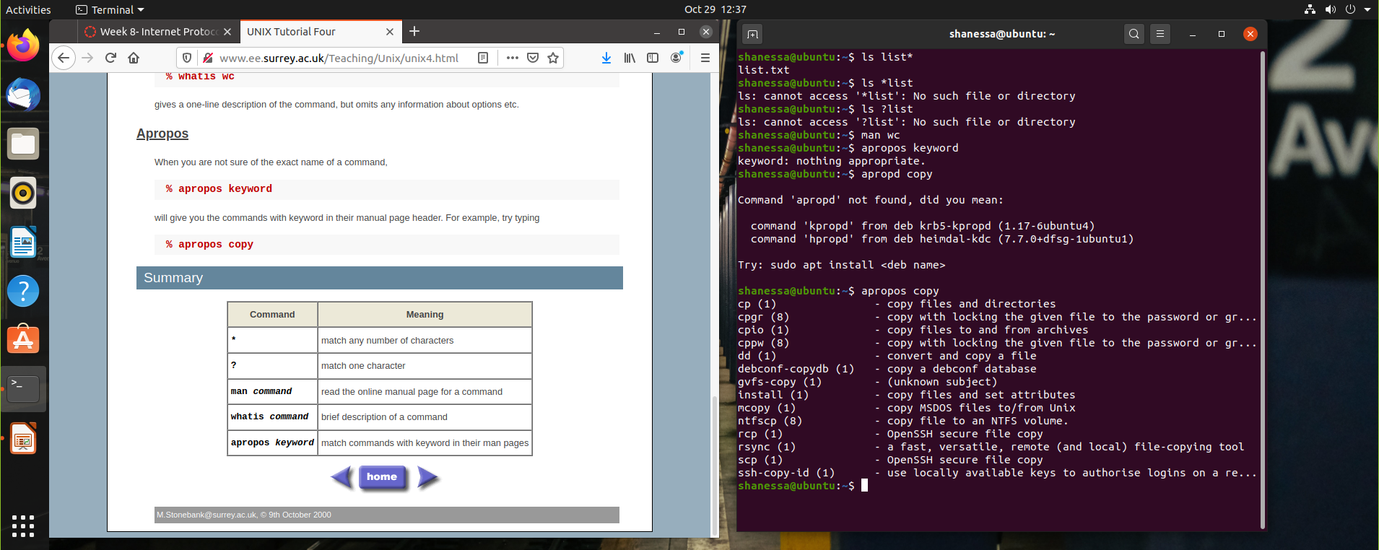

**Task 1b**: Networking exercise

Provide screenshots of all exercises.

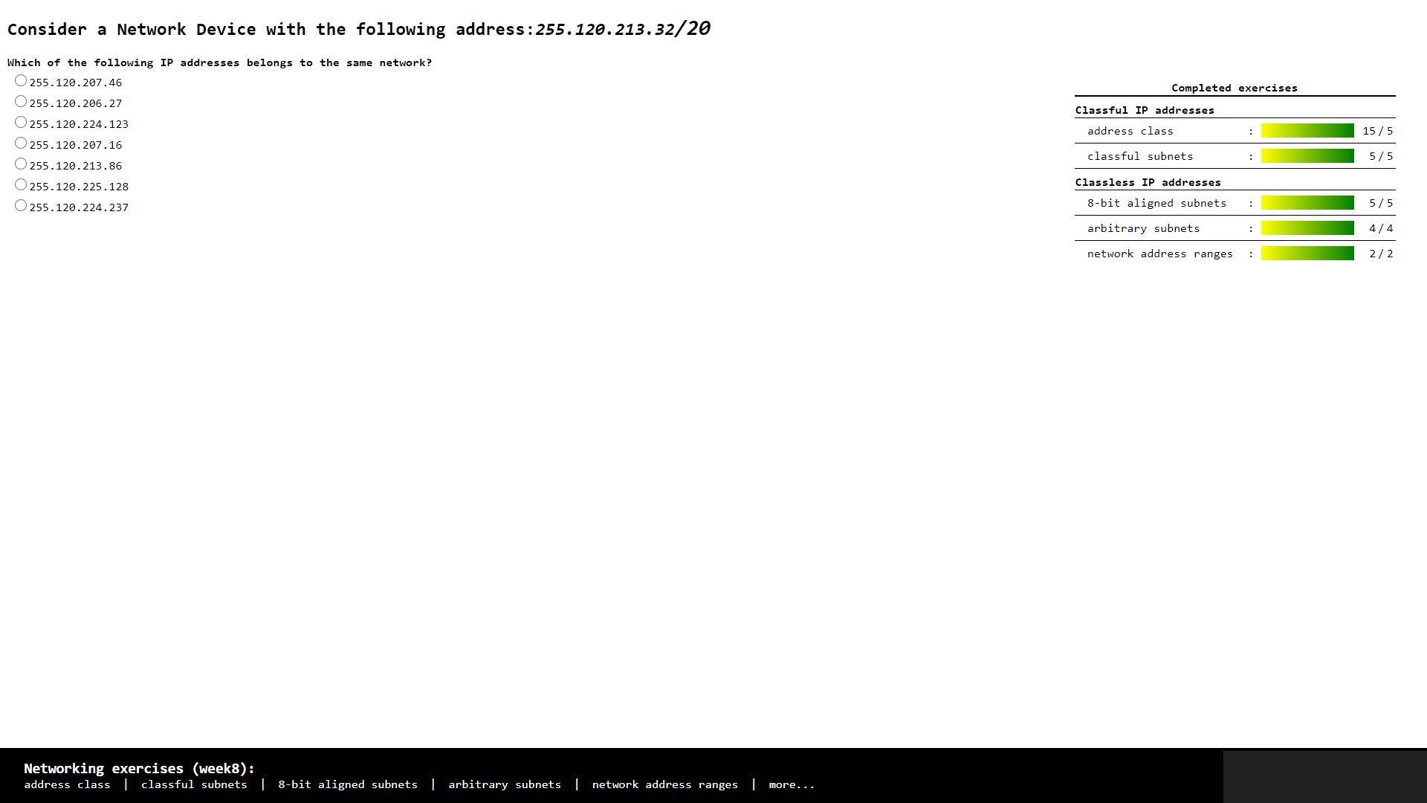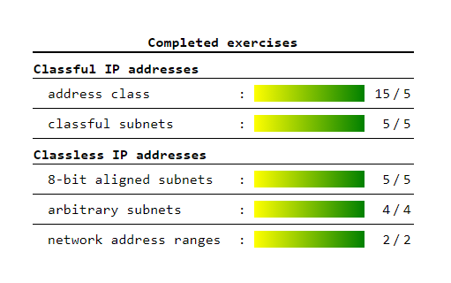

**Task 2:** Build A Simple Netkit Network

This week, we configured our Netkit to run multiple networks by using the pre-determined netkit lab. First, we learned about using the ping function, which is used to determine whether a network is connected to the computer. The ping command would allow the computer to emit packets to a specified IP address, and if the packets are reflected back, it would indicate a connection was established.

We also learned on the use of ARP caches, which are useful as a log of the many networks that may be connected to a computer in a time.

1. What is the result of the ping? Can you explain it? Provide a screenshot.

* The result of the ping is “Network is unreachable” because the subnet / the network is different, so the PC can not connect to each other.

1. Look at the ARP entries of your Node1 and Node2. Which command do you use? Which ARP entries are there?

* The command that I used is ARP
* The list on the ARP is empty because the PC are not connected to each other

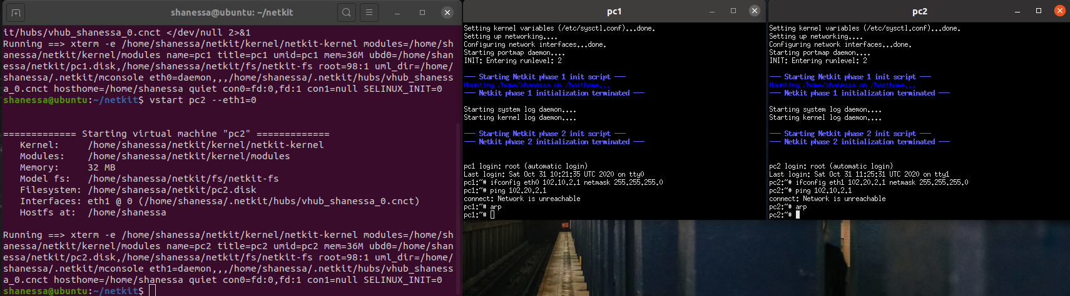

B) Configure the IP addresses of the 2 nodes by using the “ip” command explained in the theory lesson.

1. Node1 has an IP address 102.10.2.1/10
2. Node2 has an IP address 102.20.2.1/10

Check whether your configuration was successful by using ping command between these two nodes.

1. What is the result of the ping? Can you explain it? Provide a screenshot of your configured interfaces.

* The result of the ping is succeeded, it’s working. The PC are connected to each other.

1. Look at the ARP entries of your Node1 and Node2. Which ARP entries are there?

* The ARP of PC 2 already on the PC 1 and vice versa.

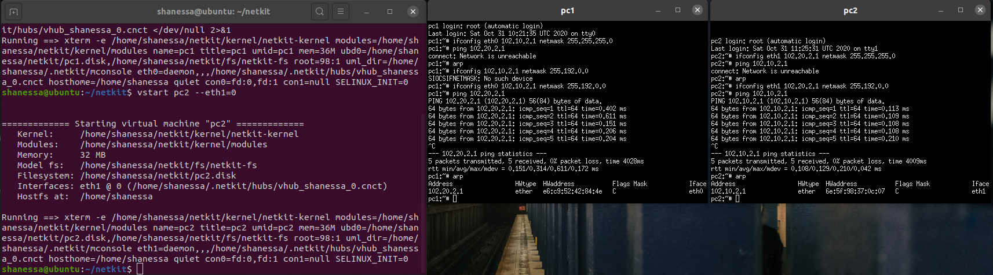

C) Configure both nodes to have a subnet mask 255.255.255.0, and change the IP address of Node2 in such a way that the ping between them is successful.

1. Provide a screenshot of your configuration and successful ping.
2. After successful ping ARP entries of both nodes should be changed. Provide a screenshot of the new ARP situation and explain it. What is the command to clear the ARP cache again

* I changed the IP address of PC 2 and the ARP list showed us the new IP address of PC 2 on the PC 1. And when we want to clear the ARP cache we can use command “arp -d and put the IP address”, e.g. arp -d 102.10.2.2

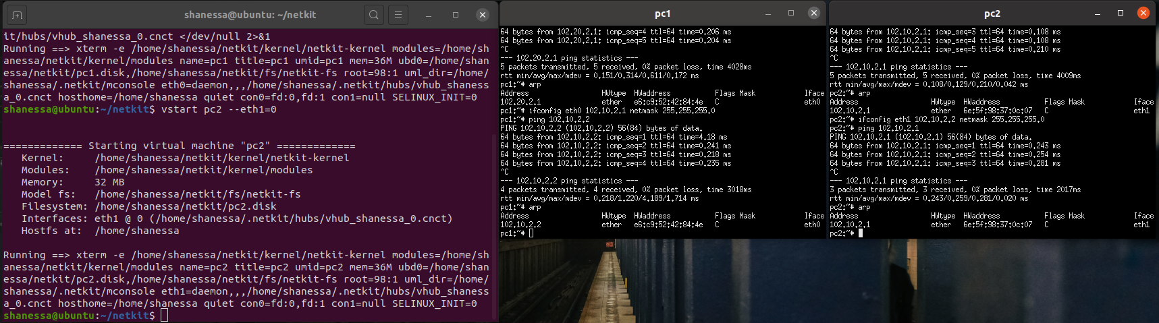

Table 1 : IPv4 address ranges per student group

|  |  |  |  |
| --- | --- | --- | --- |
| Group | LANA | LANB | LANC |
| 1 | 10.1.0.0/16 | 172.16.1.0/24 | 192.168.1.0/24 |
| 2 | 10.2.0.0/16 | 172.16.2.0/24 | 192.168.2.0/24 |
| … | | | |
| n | 10.n.0.0/16 | 172.16.n.0/24 | 192.168.n.0/24 |

This week, we configured multiple networks in a single computer using the ifconfig command on our netkit lab startup files. We assigned it as according to **Table 1**, in this case n= 10 as it is our group number.

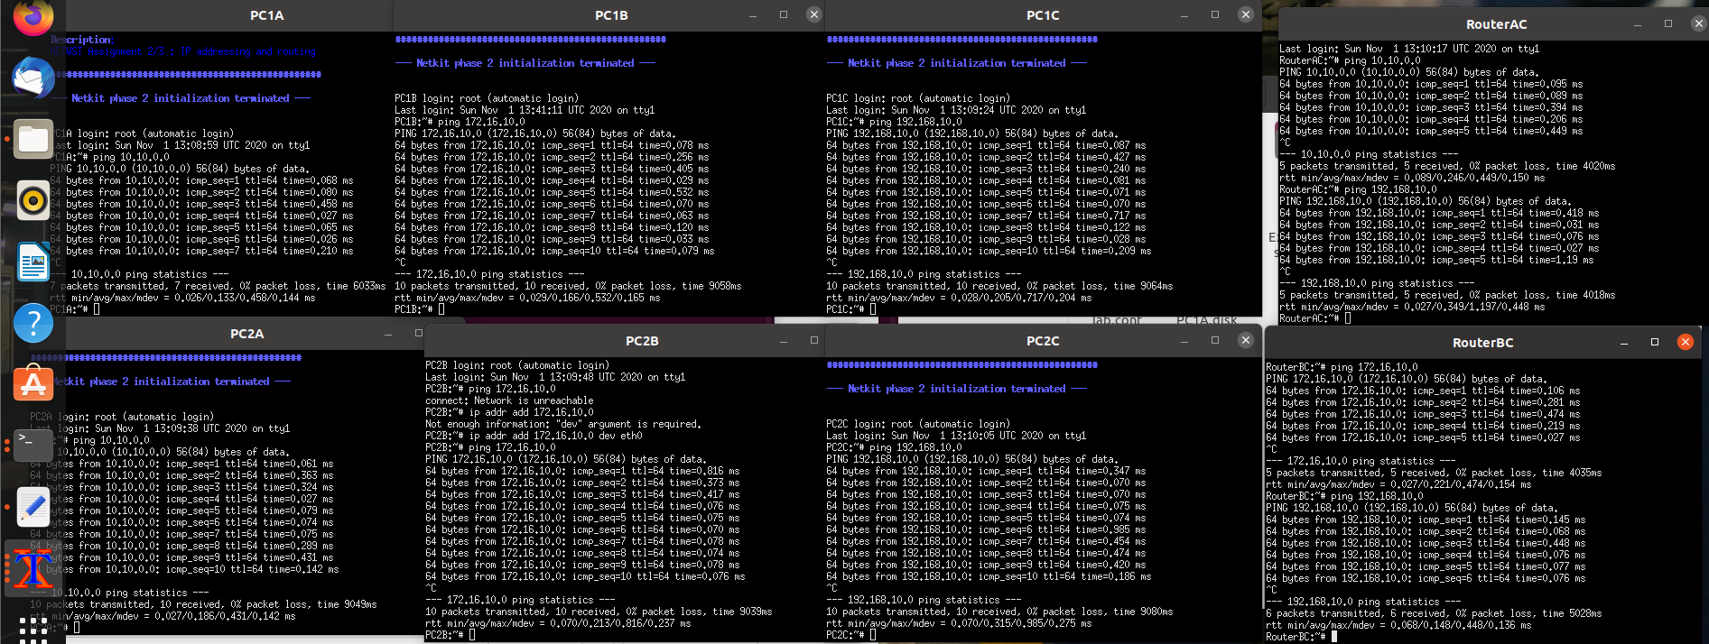

Network Diagram

**Task 4**: CIDR IP Addressing Exercises

1. Suppose we have IP address 122.33.196.145/24

Fill in the following items for this address:

1. Network Address : **122.33.196.0**
2. Broadcast Address : **122.33.196.255**
3. Subnet Mask : **255.255.255.0**

2. Suppose we have IP address 163.249.223.229/25

Fill in the following items for this address:

1. Network Address : **163.249.223.128**
2. First Host : **163.249.233.129**
3. Last Host : **163.249.223.254**
4. Broadcast Address : **163.249.233.255**